What is HTML?

HTML is the standard markup language for creating Web pages.

* HTML stands for Hyper Text Markup Language
* HTML describes the structure of Web pages using markup
* HTML elements are the building blocks of HTML pages
* HTML elements are represented by tags
* HTML tags label pieces of content such as "heading", "paragraph", "table", and so on
* Browsers do not display the HTML tags, but use them to render the content of the page

Structure of HTML5

<!DOCTYPE html>  
<html>  
<head>  
<title>Page Title</title>  
</head>  
<body>  
</body>  
</html>

* The <!DOCTYPE html> declaration defines this document to be HTML5
* The <html> element is the root element of an HTML page
* The <head> element contains meta information about the document
* The <title> element specifies a title for the document
* The <body> element contains the visible page content

## HTML Versions

Since the early days of the web, there have been many versions of HTML:

|  |  |
| --- | --- |
| Version | Year |
| HTML | 1991 |
| HTML 2.0 | 1995 |
| HTML 3.2 | 1997 |
| HTML 4.01 | 1999 |
| XHTML | 2000 |
| HTML5 | 2014 |

There are many differences between HTML and HTML5 which are discussed below:

|  |  |
| --- | --- |
| **HTML** | **HTML5** |
| It didn’t support audio and video without the use of flash player support. | It supports audio and video controls with the use of <audio> and <video> tags. |
| It uses cookies to store temporary data. | It uses SQL databases and application cache to store offline data. |
| Does not allow JavaScript to run in browser. | Allows JavaScript to run in background. This is possible due to JS Web worker API in HTML5. |
| Vector graphics is possible in HTML with the help of various technologies such as VML, Silver-light, Flash, etc. | Vector graphics is additionally an integral a part of HTML5 like SVG and canvas. |
| It does not allow drag and drop effects. | It allows drag and drop effects. |
| Not possible to draw shapes like circle, rectangle, triangle etc. | HTML5 allows to draw shapes like circle, rectangle, triangle etc. |
| It works with all old browsers. | It supported by all new browser like Firefox, Mozilla, Chrome, Safari, etc. |
| Older version of HTML is less mobile-friendly. | HTML5 language is more mobile-friendly. |
| Doctype declaration is too long and complicated. | Doctype declaration is quite simple and easy. |
| Elements like nav, header were not present. | New element for web structure like nav, header, footer etc. |
| Character encoding is long and complicated. | Character encoding is simple and easy. |
| It is almost impossible to get true GeoLocation of user with the help of browser. | One can track the GeoLocation of a user easily by using JS GeoLocation API. |
| It can not handle inaccurate syntax. | It is capable of handling inaccurate syntax. |
| Attributes like charset, async and ping are absent in HTML. | Attributes of charset, async and ping are a part of HTML 5. |

What is an HTML Element?

An HTML element is defined by a start tag, some content, and an end tag:

<tagname> Content goes here... </tagname>

The HTML **element** is everything from the start tag to the end tag:

<h1>My First Heading</h1>

<p>My first paragraph.</p>

|  |  |  |
| --- | --- | --- |
| **Start tag** | **Element content** | **End tag** |
| <h1> | My First Heading | </h1> |
| <p> | My first paragraph. | </p> |
| <br> | *none* | *none* |

**Note:** Some HTML elements have no content (like the <br> element). These elements are called empty elements. Empty elements do not have an end tag!

## The <!DOCTYPE> Declaration

The <!DOCTYPE> declaration represents the document type, and helps browsers to display web pages correctly.

It must only appear once, at the top of the page (before any HTML tags).

The <!DOCTYPE> declaration is not case sensitive.

The <!DOCTYPE> declaration for HTML5 is:

<!DOCTYPE html>

**COMMENT IN HTML**

<!-- Write your comments here -->

# HTML Ordered List | HTML Numbered List

**HTML Ordered List** or Numbered List displays elements in numbered format. The HTML ol tag is used for ordered list. We can use ordered list to represent items either in numerical order format or alphabetical order format, or any format where an order is emphasized. There can be different types of numbered list:

* Numeric Number (1, 2, 3)
* Capital Roman Number (I II III)
* Small Romal Number (i ii iii)
* Capital Alphabet (A B C)
* Small Alphabet (a b c)

To represent different ordered lists, there are 5 types of attributes in <ol> tag.

|  |  |
| --- | --- |
| **Type** | **Description** |
| Type "1" | This is the default type. In this type, the list items are numbered with numbers. |
| Type "I" | In this type, the list items are numbered with upper case roman numbers. |
| Type "i" | In this type, the list items are numbered with lower case roman numbers. |
| Type "A" | In this type, the list items are numbered with upper case letters. |
| Type "a" | In this type, the list items are numbered with lower case letters. |

# HTML Unordered List | HTML Bulleted List

**HTML Unordered List** or Bulleted List displays elements in bulleted format . We can use unordered list where we do not need to display items in any particular order. The HTML ul tag is used for the unordered list. There can be 4 types of bulleted list:

* disc
* circle
* square
* none

To represent different ordered lists, there are 4 types of attributes in <ul> tag.

|  |  |
| --- | --- |
| **Type** | **Description** |
| Type "disc" | This is the default style. In this style, the list items are marked with bullets. |
| Type "circle" | In this style, the list items are marked with circles. |
| Type "square" | In this style, the list items are marked with squares. |
| Type "none" | In this style, the list items are not marked . |

**HTML Description List** or Definition List displays elements in definition form like in dictionary. The <dl>, <dt> and <dd> tags are used to define description list.

The 3 HTML description list tags are given below:

1. **<dl> tag** defines the description list.
2. **<dt> tag** defines data term.
3. **<dd> tag** defines data definition (description).

# HTML Table Colspan & Rowspan

HTML tables can have cells that spans over multiple rows and/or columns

|  |  |  |
| --- | --- | --- |
| **2022** | | |
|  |  |  |
| **FIESTA** | |  |
|  |
|  |  |  |

## HTML Table - Colspan

To make a cell span over multiple columns, use the colspan attribute:

<table border=”1”>  
  <tr>  
    <th colspan="2">Name</th>  
    <th>Age</th>  
  </tr>  
  <tr>  
    <td>Jill</td>  
    <td>Smith</td>  
    <td>43</td>  
  </tr>  
  <tr>  
    <td>Eve</td>  
    <td>Jackson</td>  
    <td>57</td>  
  </tr>  
</table>

**Note:** The value of the colspan attribute represents the number of columns to span.

|  |  |  |
| --- | --- | --- |
| **Name** | | **Age** |
| Jill | Smith | 43 |
| Eve | Jackson | 57 |

## HTML Table - Rowspan

To make a cell span over multiple rows, use the rowspan attribute:

<table border=”1”>  
  <tr>  
    <th>Name</th>  
    <td>Jill</td>  
  </tr>  
  <tr>  
    <th rowspan="2">Phone</th>  
    <td>555-1234</td>  
  </tr>  
  <tr>  
    <td>555-8745</td>  
</tr>  
</table>

**Note:** The value of the rowspan attribute represents the number of rows to span.

|  |  |
| --- | --- |
| **Name** | Jill |
| **Phone** | 555-1234 |
| 555-8745 |

# The <base> element

<!DOCTYPE html>

<html>

<head>

<base href="https://www.w3schools.com/" target="_blank">

</head>

<body>

<h1>The base element</h1>

<p><img src="images/stickman.gif" width="24" height="39" alt="Stickman"> - Notice that we have only specified a relative address for the image. Since we have specified a base URL in the head section, the browser will look for the image at "https://www.w3schools.com/images/stickman.gif".</p>

<p><a href="tags/tag_base.asp">HTML base tag</a> - Notice that the link opens in a new window, even if it has no target="_blank" attribute. This is because the target attribute of the base element is set to "_blank".</p>

</body>

</html>

**Output:**

# The base element

Stickman - Notice that we have only specified a relative address for the image. Since we have specified a base URL in the head section, the browser will look for the image at "https://www.w3schools.com/images/stickman.gif".

[HTML base tag](https://www.w3schools.com/tags/tag_base.asp) - Notice that the link opens in a new window, even if it has no target="_blank" attribute. This is because the target attribute of the base element is set to "_blank".

## Definition and Usage

The <base> tag specifies the base URL and/or target for all relative URLs in a document.

The <base> tag must have either an href or a target attribute present, or both.

There can only be one single <base> element in a document, and it must be inside the <head> element.

**<link> tag**

<!DOCTYPE html>

<html>

<head>

<link rel="stylesheet" href="styles.css">

</head>

<body>

<h1>Hello World!</h1>

<h2>I am formatted with a linked style sheet.</h2>

<p>Me too!</p>

</body>

</html>



## Definition and Usage

The <link> tag defines the relationship between the current document and an external resource.

The <link> tag is most often used to link to external style sheets or to add a [favicon](https://www.w3schools.com/html/html_favicon.asp) to your website.

The <link> element is an empty element, it contains attributes only.

## Text Formatting TAGS

## <P> Tags

## The paragraph defines whole textual information and is also a part of HTML text formatting elements. Of course, you can have more than one paragraph on your website! Bear in mind that every new paragraph you write begins from a new line.

## Bold Text

Anything that appears within **<b>...</b>** element, is displayed in bold as shown below −

### Example

<!DOCTYPE html>

<html>

<head>

<title>Bold Text Example</title>

</head>

<body>

<p>The following word uses a <b>bold</b> typeface.</p>

</body>

</html>

This will produce the following result −The following word uses a **bold** typeface.

## Italic Text

Anything that appears within **<i>...</i>** element is displayed in italicized as shown below −

### Example

<!DOCTYPE html>

<html>

<head>

<title>Italic Text Example</title>

</head>

<body>

<p>The following word uses an <i>italicized</i> typeface.</p>

</body>

</html>

This will produce the following result −The following word uses a*italicized* typeface.

## Underlined Text

Anything that appears within **<u>...</u>** element, is displayed with underline as shown below −

### Example

<!DOCTYPE html>

<html>

<head>

<title>Underlined Text Example</title>

</head>

<body>

<p>The following word uses an <u>underlined</u> typeface.</p>

</body>

</html>

This will produce the following result −The following word uses aunderlined typeface.

## Strike Text

Anything that appears within **<strike>...</strike>** element is displayed with strikethrough, which is a thin line through the text as shown below −

### Example

<!DOCTYPE html>

<html>

<head>

<title>Strike Text Example</title>

</head>

<body>

<p>The following word uses a <strike>strikethrough</strike> typeface.</p>

</body>

</html>

This will produce the following result −The following word uses a ~~strikethrough~~ typeface.

## Monospaced Font

The content of a **<tt>...</tt>** element is written in monospaced font. Most of the fonts are known as variable-width fonts because different letters are of different widths (for example, the letter 'm' is wider than the letter 'i'). In a monospaced font, however, each letter has the same width.

### Example

<!DOCTYPE html>

<html>

<head>

<title>Monospaced Font Example</title>

</head>

<body>

<p>The following word uses a <tt>monospaced</tt> typeface.</p>

</body>

</html>

This will produce the following result −The following word uses a mo no spaced typeface.

## Superscript Text

The content of a **<sup>...</sup>** element is written in superscript; the font size used is the same size as the characters surrounding it but is displayed half a character's height above the other characters.

### Example

<!DOCTYPE html>

<html>

<head>

<title>Superscript Text Example</title>

</head>

<body>

<p>The following word uses a <sup>superscript</sup> typeface.</p>

</body>

</html>

This will produce the following result −The following word uses a superscript typeface.

## Subscript Text

The content of a **<sub>...</sub>** element is written in subscript; the font size used is the same as the characters surrounding it, but is displayed half a character's height beneath the other characters.

### Example

<!DOCTYPE html>

<html>

<head>

<title>Subscript Text Example</title>

</head>

<body>

<p>The following word uses a <sub>subscript</sub> typeface.</p>

</body>

</html>

This will produce the following result −The following word uses a subscript typeface.

## Inserted Text

Anything that appears within **<ins>...</ins>** element is displayed as inserted text.

## Deleted Text

Anything that appears within **<del>...</del>** element, is displayed as deleted text.

### Example

<!DOCTYPE html>

<html>

<head>

<title>Inserted Text Example</title>

</head>

<body>

<p>I want to drink <del>cola</del><ins>wine</ins></p>

</body>

</html>

This will produce the following result −I want to drink ~~cola~~wine

## Larger Text

The content of the **<big>...</big>** element is displayed one font size larger than the rest of the text surrounding it as shown below −

### Example

<!DOCTYPE html>

<html>

<head>

<title>Larger Text Example</title>

</head>

<body>

<p>The following word uses a <big>big</big> typeface.</p>

</body>

</html>

This will produce the following result −The following word uses a big typeface.

## Smaller Text

The content of the **<small>...</small>** element is displayed one font size smaller than the rest of the text surrounding it as shown below −

### Example

<!DOCTYPE html>

<html>

<head>

<title>Smaller Text Example</title>

</head>

<body>

<p>The following word uses a <small>small</small> typeface.</p>

</body>

</html>

This will produce the following result −The following word uses a small typeface.

## <q> tags

The [<q>](https://www.bitdegree.org/learn/html-quote-tag/) element inserts quotation marks around the text. The full name of this tag is “quote” so, it is used for inserting quotes, citing and so on. However, if you’re not quoting some other text, you shouldn’t use this tag just for adding quotation marks. You can insert some attributes to this element for suiting your needs.

<!DOCTYPE html>

<html>

<body>

<p>WWF's goal is to:

<q>Build a future where people live in harmony with nature.</q>

We hope they succeed.</p>

</body>

</html>

WWF's goal is to: “Build a future where people live in harmony with nature.” We hope they succeed.

## <blockquote> tags

The [<blockquote>](https://www.bitdegree.org/learn/blockquote-html/) element is quite similar to [<q>](https://www.bitdegree.org/learn/html-quote-tag/) tag, and it works almost in the same method. However, while using this HTML text formatting tag, bear in mind, that this quote will appear on a new line and have an intend for each line it contains. It makes it look like a block of text, and this is where its name came from.

<!DOCTYPE html>

<html>

<body>

<h1>About WWF</h1>

<p>Here is a quote from WWF's website:</p>

<blockquote cite="http://www.worldwildlife.org/who/index.html">

For 50 years, WWF has been protecting the future of nature. The world's leading conservation organization, WWF works in 100 countries and is supported by 1.2 million members in the United States and close to 5 million globally.

</blockquote>

</body>

</html>

# <marquee> Tag

The HTML <marquee> tag is used for scrolling piece of text or image displayed either horizontally across or vertically down your web site page depending on the settings.

## Example

<!DOCTYPE html>

<html>

<head>

<title>HTML marquee Tag</title>

</head>

<body>

<marquee>This is basic example of marquee</marquee>

<marqueedirection="up">The direction of text will be from bottom to top.</marquee>

</body>

</html>

## Specific Attributes

The HTML <marquee> tag also supports the following additional attributes −

|  |  |  |
| --- | --- | --- |
| **Attribute** | **Value** | **Description** |
| behavior | scroll slide alternate | Defines the type of scrolling. |
| bgcolor | rgb(x,x,x) #xxxxxx colorname | *Deprecated* − Defines the direction of scrolling the content. |
| direction | up down left right | Defines the direction of scrolling the content. |
| height | pixels or % | Defines the height of marquee. |
| hspace | pixels | Specifies horizontal space around the marquee. |
| loop | number | Specifies how many times to loop. The default value is INFINITE, which means that the marquee loops endlessly. |
| scrolldelay | seconds | Defines how long to delay between each jump. |
| scrollamount | number | Defines how how far to jump. |
| width | pixels or % | Defines the width of marquee. |
| vspace | pixels | Specifies vertical space around the marquee. |

# HTML Block and Inline Elements

# <header> Tag

The <header> element represents a container for introductory content or a set of navigational links.

A <header> element typically contains:

* one or more heading elements (<h1> - <h6>)
* logo or icon
* authorship information

You can have several <header> elements in one document.

<!DOCTYPE html>

<html>

<body>

<article>

<header>

<h1>Most important heading here</h1>

<h3>Less important heading here</h3>

<p>Some additional information here.</p>

</header>

<p>LoremIpsumdolor set amet....</p>

</article>

</body>

</html>

# Most important heading here

### Less important heading here

Some additional information here.

LoremIpsumdolor set amet....

# <footer> Tag

The <footer> tag defines a footer for a document or section.

A <footer> element should contain information about its containing element.

A <footer> element typically contains:

* authorship information
* copyright information
* contact information
* sitemap
* back to top links
* related documents

You can have several <footer> elements in one document.

<!DOCTYPE html>

<html>

<body>

<footer>

<p>Posted by: HegeRefsnes</p>

<p>Contact information: <a href="mailto:someone@example.com">someone@example.com</a>.</p>

</footer>

<p><strong>Note:</strong> The footer tag is not supported in Internet Explorer 8 and earlier versions.</p>

</body>

</html>

Posted by: HegeRefsnes

Contact information: [someone@example.com](mailto:someone@example.com).

**Note:** The footer tag is not supported in Internet Explorer 8 and earlier versions.

# <h1> to <h6> Tags

The <h1> to <h6> tags are used to define HTML headings.

<h1> defines the most important heading. <h6> defines the least important heading.

## Attributes

|  |  |  |
| --- | --- | --- |
| **Attribute** | **Value** | **Description** |
| [align](https://www.w3schools.com/tags/att_hn_align.asp) | left center right justify | Not supported in HTML5. Specifies the alignment of a heading |

<!DOCTYPE html>

<html>

<body>

<h1>This is heading 1</h1>

<h2>This is heading 2</h2>

<h3>This is heading 3</h3>

<h4>This is heading 4</h4>

<h5>This is heading 5</h5>

<h6>This is heading 6</h6>

</body>

</html>

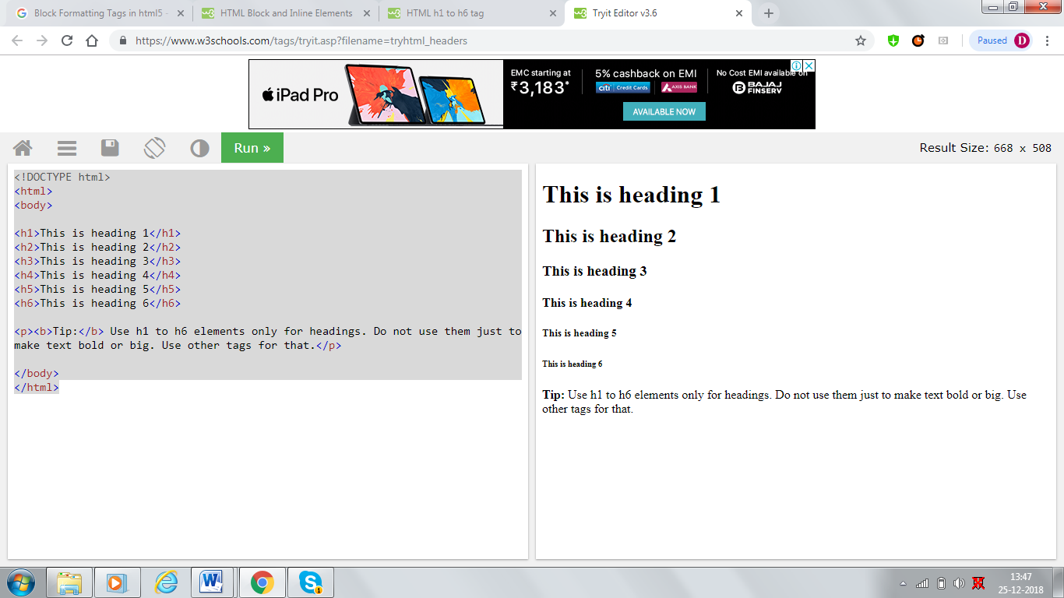

# <hr> Tag

The <hr> tag defines a thematic break in an HTML page. The <hr> element is used to separate content (or define a change) in an HTML page.

## Attributes

|  |  |  |
| --- | --- | --- |
| **Attribute** | **Value** | **Description** |
| [align](https://www.w3schools.com/tags/att_hr_align.asp) | left center right | Not supported in HTML5. Specifies the alignment of a <hr> element |
| [noshade](https://www.w3schools.com/tags/att_hr_noshade.asp) | noshade | Not supported in HTML5. Specifies that a <hr> element should render in one solid color (noshaded), instead of a shaded color |
| [size](https://www.w3schools.com/tags/att_hr_size.asp) | *Pixels* | Not supported in HTML5. Specifies the height of a <hr> element |
| [width](https://www.w3schools.com/tags/att_hr_width.asp) | *pixels %* | Not supported in HTML5. Specifies the width of a <hr> element |

<!DOCTYPE html>

<html>

<body>

<h1>HTML</h1>

<p>HTML is a language for describing web pages.</p>

<hr>

<h1>CSS</h1>

<p>CSS defines how to display HTML elements.</p>

</body>

</html>

# HTML

HTML is a language for describing web pages.

CSS

CSS defines how to display HTML elements.

# <pre> Tag

The <pre> tag defines preformatted text.

Text in a <pre> element is displayed in a fixed-width font (usually Courier), and it preserves both spaces and line breaks.

## Attributes

|  |  |  |
| --- | --- | --- |
| **Attribute** | **Value** | **Description** |
| [width](https://www.w3schools.com/tags/att_pre_width.asp) | *number* | Not supported in HTML5. Specifies the maximum number of characters per line |

<!DOCTYPE html>

<html>

<body>

<pre>

Text in a pre element

is displayed in a fixed-width

font, and it preserves

both spaces and

line breaks

</pre>

</body>

</html>

Text in a pre element

is displayed in a fixed-width

font, and it preserves

both spaces and

line breaks

# <section> Tag

The <section> tag defines sections in a document, such as chapters, headers, footers, or any other sections of the document.

<!DOCTYPE html>

<html>

<body>

<section>

<h1>WWF</h1>

<p>The World Wide Fund for Nature (WWF) is an international organization working on issues regarding the conservation, research and restoration of the environment, formerly named the World Wildlife Fund. WWF was founded in 1961.</p>

</section>

<section>

<h1>WWF's Panda symbol</h1>

<p>The Panda has become the symbol of WWF. The well-known panda logo of WWF originated from a panda named Chi Chi that was transferred from the Beijing Zoo to the London Zoo in the same year of the establishment of WWF.</p>

</section>

</body>

</html>

# WWF

The World Wide Fund for Nature (WWF) is an international organization working on issues regarding the conservation, research and restoration of the environment, formerly named the World Wildlife Fund. WWF was founded in 1961.

# WWF's Panda symbol

The Panda has become the symbol of WWF. The well-known panda logo of WWF originated from a panda named Chi Chi that was transferred from the Beijing Zoo to the London Zoo in the same year of the establishment of WWF.

# <abbr> Tag

The <abbr> tag defines an abbreviation or an acronym, like "Mr.", "Dec.", "ASAP", "ATM".

<!DOCTYPE html>

<html>

<body>

<p>The <abbr title="World Health Organization">WHO</abbr> was founded in 1948.</p>

</body>

</html>

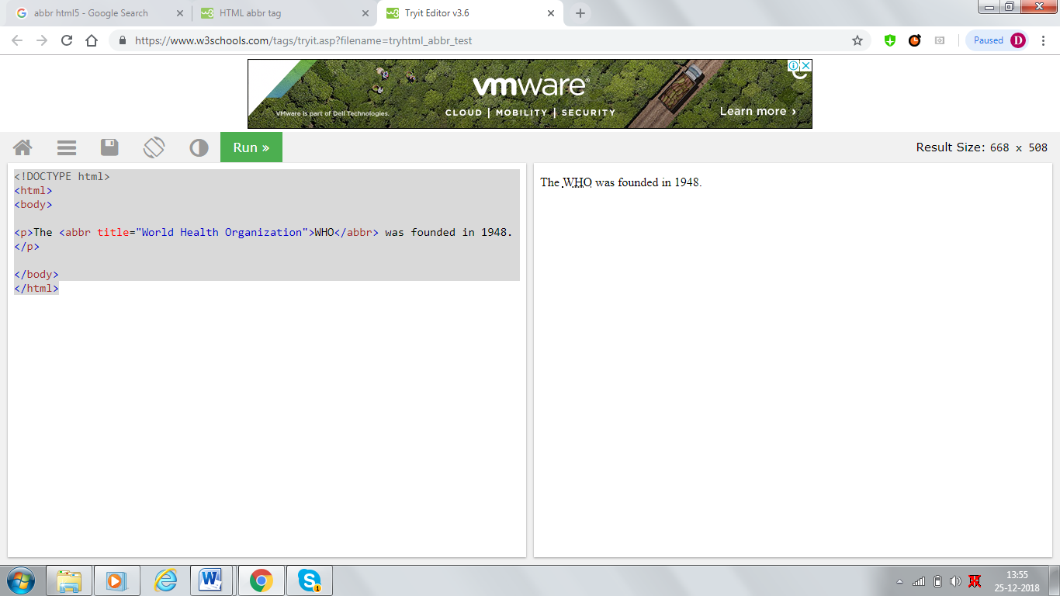

# HTML lists

Lists are used to group together related pieces of information so they are clearly associated with each other and easy to read. In modern web development, lists are workhorse elements, frequently used for navigation as well as general content.

Lists are good from a structural point of view as they help create a well-structured, more accessible, easy-to-maintain document. They are also useful because they provide specialized elements to which you can attach CSS styles. Finally, semantically correct lists help visitors read your web site, and they simplify maintenance when your pages need to be updated.

**The three list types**

There are three list types in HTML:

**unordered list** — used to group a set of related items in no particular order

**ordered list** — used to group a set of related items in a specific order

**description list** — used to display name/value pairs such as terms and definitions

Each list type has a specific purpose and meaning in a web page.

**Unordered lists**

*Unordered* (bulleted) lists are used when a set of items can be placed in any order. An example is a shopping list:

* milk
* bread
* butter
* coffee beans

Unordered lists use one set of <ul></ul> tags wrapped around one or more sets of <li></li> tags:

**<ul>**

**<li>bread</li>**

**<li>coffee beans</li>**

**<li>milk</li>**

**<li>butter</li>**

**</ul>**

|  |  |  |
| --- | --- | --- |
| **Attribute** | **Value** | **Description** |
| [compact](https://www.w3schools.com/tags/att_ul_compact.asp) | compact | Not supported in HTML5. Specifies that the list should render smaller than normal |
| [type](https://www.w3schools.com/tags/att_ul_type.asp) | disc square circle | Not supported in HTML5. Specifies the kind of marker to use in the list |

**Ordered lists**

*Ordered* (numbered) lists are used to display a list of items that should be in a specific order. An example would be cooking instructions:

1. Gather ingredients
2. Mix ingredients together
3. Place ingredients in a baking dish
4. Bake in oven for an hour
5. Remove from oven
6. Allow to stand for ten minutes
7. Serve

**<ol>**

**<li>Gather ingredients</li>**

**<li>Mix ingredients together</li>**

**<li>Place ingredients in a baking dish</li>**

**<li>Bake in oven for an hour</li>**

**<li>Remove from oven</li>**

**<li>Allow to stand for ten minutes</li>**

**<li>Serve</li>**

**</ol>**

|  |  |  |
| --- | --- | --- |
| **Attribute** | **Value** | **Description** |
| [compact](https://www.w3schools.com/tags/att_ol_compact.asp) | compact | Not supported in HTML5. Specifies that the list should render smaller than normal |
| [start](https://www.w3schools.com/tags/att_ol_start.asp) | *number* | Specifies the start value of an ordered list |
| [type](https://www.w3schools.com/tags/att_ol_type.asp) | 1 A a I i | Specifies the kind of marker to use in the list |

Ordered lists can be displayed with several sequencing options. The default in most browsers is decimal numbers, but there are others available:

* Letters
  + Lowercase ascii letters (a, b, c…)
  + Uppercase ascii letters (A, B, C…).
  + Lowercase classical Greek: (έ, ή, ί…)
* Numbers
  + Decimal numbers (1, 2, 3…)
  + Decimal numbers with leading zeros (01, 02, 03…)
  + Lowercase Roman numerals (i, ii, iii…)
  + Uppercase Roman numerals (I, II, III…)
  + Traditional Georgian numbering (an, ban, gan…)
  + Traditional Armenian numbering (mek, yerku, yerek…)

**Description lists**

*Description lists* (previously called *definition lists*, but renamed in HTML5) associate specific names and values within a list. Examples might be items in an ingredient list and their descriptions, article authors and brief bios, or competition winners and the years in which they won. You can have as many name-value groups as you like, but there must be at least one name and at least one value in each pair.

Description lists use one set of <dl></dl> tags wrapped around one or more groups of <dt></dt> (name) and <dd></dd> (value) tags. You must pair at least one <dt></dt> with at least one <dd></dd>, and the <dt></dt>should always come first in the source order.

**<dl>**

**<dt>Name1</dt>**

**<dd>Value that applies to Name1</dd>**

**<dt>Name2</dt>**

**<dt>Name3</dt>**

**<dd>Value that applies to both Name2 and Name3</dd>**

**<dt>Name4</dt>**

**<dd>One value that applies to Name4</dd>**

**<dd>Another value that applies to Name4</dd>**

**</dl>**

**Result:**

**Name1**

**Value that applies to Name1**

**Name2**

**Name3**

**Value that applies to both Name2 and Name3**

**Name4**

**One value that applies to Name4**

**Another value that applies to Name4**

**HTML list advantages**

* Flexibility: If you have to change the order of the list items in an ordered list, you simply move around the list item elements; when the browser renders the list, it will be properly ordered.
* Styling: Using an HTML list allows you to style the list properly using CSS. The list item tags <li> are different from the other tags in your document, so you can specifically target CSS rules to them.
* Semantics: HTML lists give the content the proper semantic structure. This has important benefits, such as allowing screen readers to tell users with visual impairments that they are reading a list, rather than just reading out a confusing jumble of text and numbers.

To put it another way, don’t code list items using regular text tags. Using text instead of a list makes more work for you and can create problems for your document’s readers. So if your document needs a list, you should use the correct HTML list format.

## HTML Links - Hyperlinks

HTML links are hyperlinks. You can click on a link and jump to another document. When you move the mouse over a link, the mouse arrow will turn into a little hand.

Creating a links:

* Links are created in a web page by using the <A> and </A>tag.
* Anything returns between the <a> compared tag becameshyperlinkor hotspot.
* Documents to be navigated needs to be specified.
* By using the HREF attribute of the <A>, the next navigation web page or image can be specified. <A HREF=”filename”></A>

Types of links: There are three types of links:

1. Links to an external document: <A HREF=”file name”></A>
2. Links to a specified place within the same document: <A NAME=”location”></A>
3. Link to a particular file on a particular position:<A HREF=”URL”#”location”</A>

|  |  |  |
| --- | --- | --- |
| **Attribute** | **Value** | **Description** |
| crossorigin | anonymous use-credentials | Specifies how the element handles cross-origin requests |
| [href](https://www.w3schools.com/tags/att_link_href.asp) | *URL* | Specifies the location of the linked document |
| [hreflang](https://www.w3schools.com/tags/att_link_hreflang.asp) | *language_code* | Specifies the language of the text in the linked document |
| [media](https://www.w3schools.com/tags/att_link_media.asp) | media_query | Specifies on what device the linked document will be displayed |
| [rel](https://www.w3schools.com/tags/att_link_rel.asp) | alternate author dns-prefetch help icon license next pingback preconnect prefetch preload prerender prev search stylesheet | Required. Specifies the relationship between the current document and the linked document |
| [sizes](https://www.w3schools.com/tags/att_link_sizes.asp) | *Height*x*Width* any | Specifies the size of the linked resource. Only for rel="icon" |
| [target](https://www.w3schools.com/tags/att_link_target.asp) | _blank _self _top _parent *frame_name* | Not supported in HTML5. Specifies where the linked document is to be loaded |
| [type](https://www.w3schools.com/tags/att_link_type.asp) | media_type | Specifies the media type of the linked document |

<!DOCTYPE html>

<html>

<body>

<h2>HTML Links</h2>

<a href="Html1.html">Visit our HTML tutorial</a>

</body>

</html>

## HTML Links

[Visit our HTML tutorial](https://www.w3schools.com/html/)

# Using the #id selector / Bookmark in HTML

In [CSS](https://www.computerhope.com/jargon/c/css.htm), "#id" is a selector that may be used to designate an area that a link should point to, similar to [anchor](https://www.computerhope.com/jargon/a/anchor.htm) in [HTML](https://www.computerhope.com/jargon/h/html.htm). In the following example, you'll see how to apply #id to an [HTML tag](https://www.computerhope.com/jargon/t/tag.htm), and then how to link to it. This example will link to the first paragraph at the top of this page.

<!DOCTYPE html>

<html>

<body>

<p><a href="#C4">Jump to Chapter 4</a></p>

<h2>Chapter 1</h2>

<p>This chapter explains bablabla</p>

<h2>Chapter 2</h2>

<p>This chapter explains bablabla</p>

<h2>Chapter 3</h2>

<p>This chapter explains bablabla</p>

<h2 id="C4">Chapter 4</h2>

<p>This chapter explains bablabla</p>

<h2>Chapter 5</h2>

<p>This chapter explains bablabla</p>

<h2>Chapter 6</h2>

<p>This chapter explains bablabla</p>

<h2>Chapter 7</h2>

<p>This chapter explains bablabla</p>

<h2>Chapter 8</h2>

<p>This chapter explains bablabla</p>

<h2>Chapter 9</h2>

<p>This chapter explains bablabla</p>

<h2>Chapter 10</h2>

<p>This chapter explains bablabla</p>

<h2>Chapter 11</h2>

<p>This chapter explains bablabla</p>

<h2>Chapter 12</h2>

<p>This chapter explains bablabla</p>

</body>

</html>

[Jump to Chapter 4](https://www.w3schools.com/html/tryit.asp?filename=tryhtml_links_bookmark#C4)

## Chapter 1

This chapter explains bablabla

## Chapter 2

This chapter explains bablabla

## Chapter 3

This chapter explains bablabla

## Chapter 4

This chapter explains bablabla

## Chapter 5

This chapter explains bablabla

## Chapter 6

This chapter explains bablabla

## Chapter 7

This chapter explains bablabla

## Chapter 8

This chapter explains bablabla

## Chapter 9

This chapter explains bablabla

## Chapter 10

This chapter explains bablabla

## Chapter 11

This chapter explains bablabla

## Chapter 12

This chapter explains bablabla

## Defining an HTML Table

An HTML table is defined with the <table> tag.

Each table row is defined with the <tr> tag. A table header is defined with the <th> tag. By default, table headings are bold and centered. A table data/cell is defined with the <td> tag.

The <tr> element defines a table row, the <th> element defines a table header, and the <td> element defines a table cell.

A more complex HTML table may also include <caption>, <col>, <colgroup>, <thead>, <tfoot>, and <tbody> elements.

## Attributes

|  |  |  |
| --- | --- | --- |
| **Attribute** | **Value** | **Description** |
| [align](https://www.w3schools.com/tags/att_table_align.asp) | left center right | Not supported in HTML5. Specifies the alignment of a table according to surrounding text |
| Valign | Top  Middle  Bottom | Controls the vertical alignment of cell contain it acceptor the value |
| [bgcolor](https://www.w3schools.com/tags/att_table_bgcolor.asp) | *rgb(x,x,x) #xxxxxx colorname* | Not supported in HTML5. Specifies the background color for a table |
| [border](https://www.w3schools.com/tags/att_table_border.asp) | 1 0 | Not supported in HTML5. Specifies whether or not the table is being used for layout purposes |
| [cellpadding](https://www.w3schools.com/tags/att_table_cellpadding.asp) | *pixels* | Not supported in HTML5. Specifies the space between the cell wall and the cell content |
| [cellspacing](https://www.w3schools.com/tags/att_table_cellspacing.asp) | *pixels* | Not supported in HTML5. Specifies the space between cells |
| size | Numeric value | Specifies the Horizontal size of the textbox. |
| [maxlength](https://www.w3schools.com/tags/att_table_rules.asp) | Numeric value | Specifies the Maximum Number of Character that user can enter. |
| [Cheked](https://www.w3schools.com/tags/att_table_summary.asp) | *-* | Not supported in HTML5. This attribute should be used only for check box and Radio Button from control. It indicates checked status. |
| [width](https://www.w3schools.com/tags/att_table_width.asp) | *pixels %* | Not supported in HTML5. Specifies the width of a table |
| DISABLE | - | Turn off a from control |
| READONLY | - | Prevent the form controls value from being chang. |

<!DOCTYPE html>

<html>

<head>

<style>

</style>

</head>

<body>

<table>

<tr>

<th>Month</th>

<th>Savings</th>

</tr>

<tr>

<td>January</td>

<td>$100</td>

</tr>

<tr>

<td>February</td>

<td>$80</td>

</tr>

</table>

</body>

</html>

# HTML Forms

An HTML form contains **form elements**.

Form elements are different types of input elements, like text fields, checkboxes, radio buttons, submit buttons, and more.

## The <input> Element

The <input> element is the most important form element.

The <input> element can be displayed in several ways, depending on the **type** attribute.

Here are some examples:

|  |  |
| --- | --- |
| **Type** | **Description** |
| <input type="text"> | Defines a one-line text input field |
| <input type="radio"> | Defines a radio button (for selecting one of many choices) |
| <input type="submit"> | Defines a submit button (for submitting the form) |

## Attribute Values

|  |  |
| --- | --- |
| **Value** | **Description** |
| [button](https://www.w3schools.com/tags/att_input_type_button.asp) | Defines a clickable button (mostly used with a JavaScript to activate a script) |
| [checkbox](https://www.w3schools.com/tags/att_input_type_checkbox.asp) | Defines a checkbox |
| [color](https://www.w3schools.com/tags/att_input_type_color.asp) | Defines a color picker |
| [date](https://www.w3schools.com/tags/att_input_type_date.asp) | Defines a date control (year, month, day (no time)) |
| [datetime-local](https://www.w3schools.com/tags/att_input_type_datetime-local.asp) | Defines a date and time control (year, month, day, time (no timezone) |
| [email](https://www.w3schools.com/tags/att_input_type_email.asp) | Defines a field for an e-mail address |
| [file](https://www.w3schools.com/tags/att_input_type_file.asp) | Defines a file-select field and a "Browse" button (for file uploads) |
| [hidden](https://www.w3schools.com/tags/att_input_type_hidden.asp) | Defines a hidden input field |
| [image](https://www.w3schools.com/tags/att_input_type_image.asp) | Defines an image as the submit button |
| [month](https://www.w3schools.com/tags/att_input_type_month.asp) | Defines a month and year control (no timezone) |
| [number](https://www.w3schools.com/tags/att_input_type_number.asp) | Defines a field for entering a number |
| [password](https://www.w3schools.com/tags/att_input_type_password.asp) | Defines a password field |
| [radio](https://www.w3schools.com/tags/att_input_type_radio.asp) | Defines a radio button |
| [range](https://www.w3schools.com/tags/att_input_type_range.asp) | Defines a range control (like a slider control) |
| [reset](https://www.w3schools.com/tags/att_input_type_reset.asp) | Defines a reset button |
| [search](https://www.w3schools.com/tags/att_input_type_search.asp) | Defines a text field for entering a search string |
| [submit](https://www.w3schools.com/tags/att_input_type_submit.asp) | Defines a submit button |
| [tel](https://www.w3schools.com/tags/att_input_type_tel.asp) | Defines a field for entering a telephone number |
| [text](https://www.w3schools.com/tags/att_input_type_text.asp) | Default. Defines a single-line text field |
| [time](https://www.w3schools.com/tags/att_input_type_time.asp) | Defines a control for entering a time (no timezone) |
| [url](https://www.w3schools.com/tags/att_input_type_url.asp) | Defines a field for entering a URL |
| [week](https://www.w3schools.com/tags/att_input_type_week.asp) | Defines a week and year control (no timezone) |

## The Action Attribute

The action attribute defines the action to be performed when the form is submitted.

Normally, the form data is sent to a web page on the server when the user clicks on the submit button.

In the example above, the form data is sent to a page on the server called "/action_page.php". This page contains a server-side script that handles the form data:

<form **action="/Page1.html**">

If the action attribute is omitted, the action is set to the current page.

## The Target Attribute

The target attribute specifies if the submitted result will open in a new browser tab, a frame, or in the current window.

The default value is "_self" which means the form will be submitted in the current window.

To make the form result open in a new browser tab, use the value "_blank":

<!DOCTYPE html>

<html>

<body>

<h2>The target Attribute</h2>

<p>When submitting this form, the result will be opened in a new browser tab:</p>

<form action="/Page1.html" target="_blank">

First name:<br>

<input type="text" name="firstname" value="Mickey">

<br>

Last name:<br>

<input type="text" name="lastname" value="Mouse">

<br><br>

<input type="submit" value="Submit">

</form>

</body>

</html>

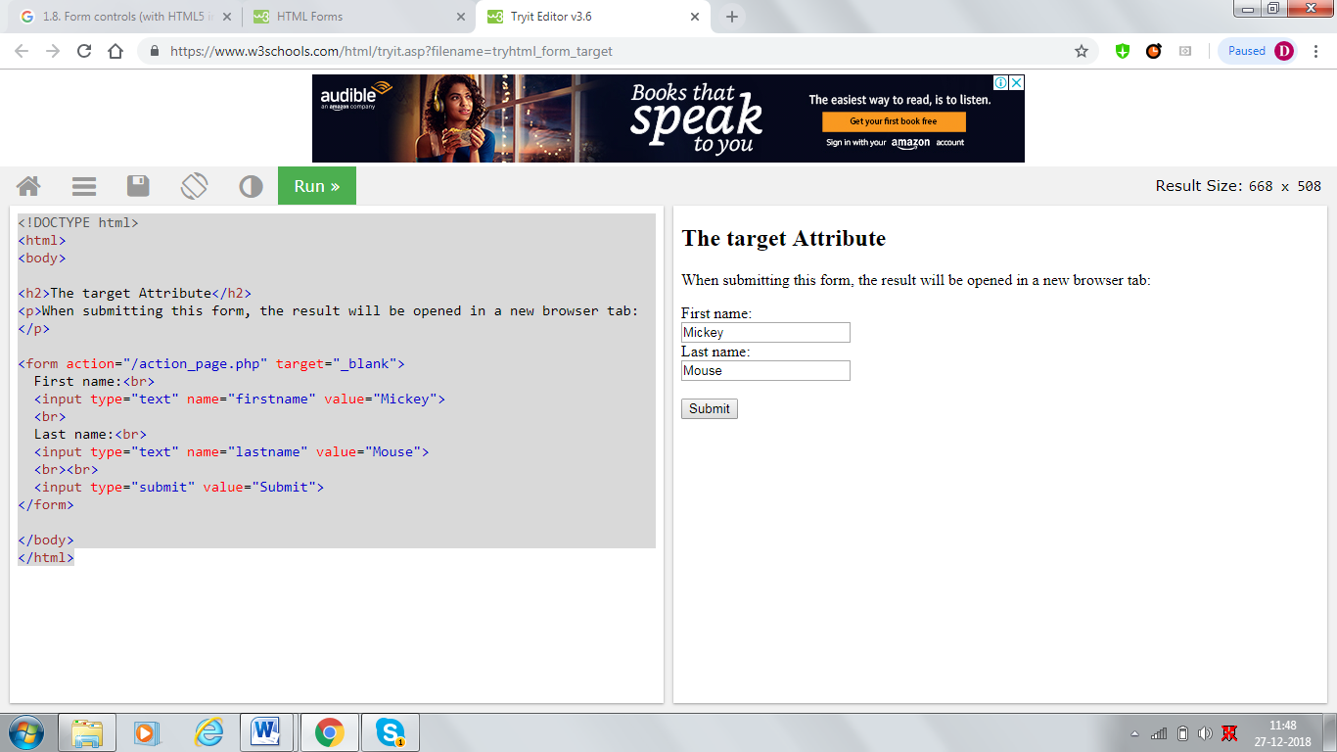

## The Method Attribute

The method attribute specifies the HTTP method (**GET**or **POST**) to be used when submitting the form data:

<!DOCTYPE html>

<html>

<body>

<h2>The method Attribute</h2>

<p>This form will be submitted using the GET method:</p>

<form action="/Page1.html" target="_blank" method="GET">

First name:<br>

<input type="text" name="firstname" value="Mickey">

<br>

Last name:<br>

<input type="text" name="lastname" value="Mouse">

<br><br>

<input type="submit" value="Submit">

</form>

<p>After you submit, notice that the form values is visible in the address bar of the new browser tab.</p>

</body>

</html>

## When to Use GET?

The default method when submitting form data is GET.

However, when GET is used, the submitted form data will be **visible in the page address field**:

/action_page.php?firstname=Mickey&lastname=Mouse

## When to Use POST?

Always use POST if the form data contains sensitive or personal information. The POST method does not display the submitted form data in the page address field.

## The Name Attribute

Each input field must have a name attribute to be submitted.

If the name attribute is omitted, the data of that input field will not be sent at all.

## Additional attributes[Section](https://developer.mozilla.org/en-US/docs/Web/HTML/Element/input/email#Additional_attributes)

In addition to the attributes that operate on all [<input>](https://developer.mozilla.org/en-US/docs/Web/HTML/Element/input) elements regardless of their type, email inputs support the following attributes:

|  |  |
| --- | --- |
| **Attribute** | **Description** |
| [maxlength](https://developer.mozilla.org/en-US/docs/Web/HTML/Element/input/email#maxlength) | The maximum number of characters the input should accept |
| [minlength](https://developer.mozilla.org/en-US/docs/Web/HTML/Element/input/email#minlength) | The minimum number of characters long the input can be and still be considered valid |
| [multiple](https://developer.mozilla.org/en-US/docs/Web/HTML/Element/input/email#multiple) | Whether or not to allow multiple, comma-separated, e-mail addresses to be entered |
| [pattern](https://developer.mozilla.org/en-US/docs/Web/HTML/Element/input/email#pattern) | A regular expression the input's contents must match in order to be valid |
| [placeholder](https://developer.mozilla.org/en-US/docs/Web/HTML/Element/input/email#placeholder) | An exemplar value to display in the input field whenever it is empty |
| [readonly](https://developer.mozilla.org/en-US/docs/Web/HTML/Element/input/email#readonly) | A Boolean attribute indicating whether or not the contents of the input should be read-only |
| [size](https://developer.mozilla.org/en-US/docs/Web/HTML/Element/input/email#size) | A number indicating how many characters wide the input field should be |
| [spellcheck](https://developer.mozilla.org/en-US/docs/Web/HTML/Element/input/email#spellcheck) | Controls whether or not to enable spell checking for the input field, or if the default spell checking configuration should be used |

# HTML <textarea>

<!DOCTYPE html>

<html>

<body>

<form action="/Page1.html" id="usrform">

Name: <input type="text" name="usrname">

<input type="submit">

</form>

<br>

<textarea rows="4" cols="50" name="comment" form="usrform">

Enter text here...</textarea>

<p>The text area above is outside the form element, but should still be a part of the form.</p>

<p><b>Note:</b> The form attribute is not supported in IE.</p>

</body>

</html>

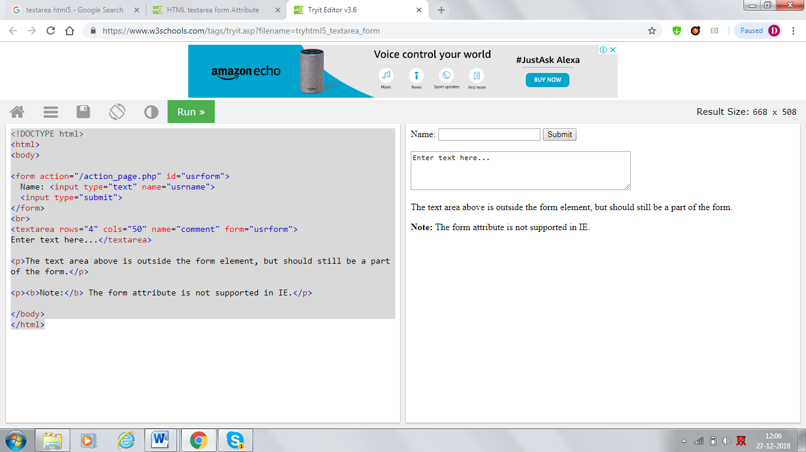

# HTML <option> selected Attribute

The selected attribute is a boolean attribute.

When present, it specifies that an option should be pre-selected when the page loads.

The pre-selected option will be displayed first in the drop-down list.

<!DOCTYPE html>

<html>

<body>

<select>

<option value="volvo">Volvo</option>

<option value="saab">Saab</option>

<option value="vw">VW</option>

<option value="audi" selected>Audi</option>

</select>

</body>

</html>

# HTML <button> form action Attribute

The formaction attribute specifies where to send the form-data when a form is submitted. This attribute overrides the form's [action](https://www.w3schools.com/tags/att_form_action.asp) attribute.

The formaction attribute is only used for buttons with type="submit".

<!DOCTYPE html>

<html>

<body>

<form action="/action_page.php" method="get">

First name: <input type="text" name="fname"><br>

Last name: <input type="text" name="lname"><br>

<button type="submit">Submit</button><br>

<button type="submit" formaction="/action_page2.php">Submit to another page</button>

</form>

</body>

</html>

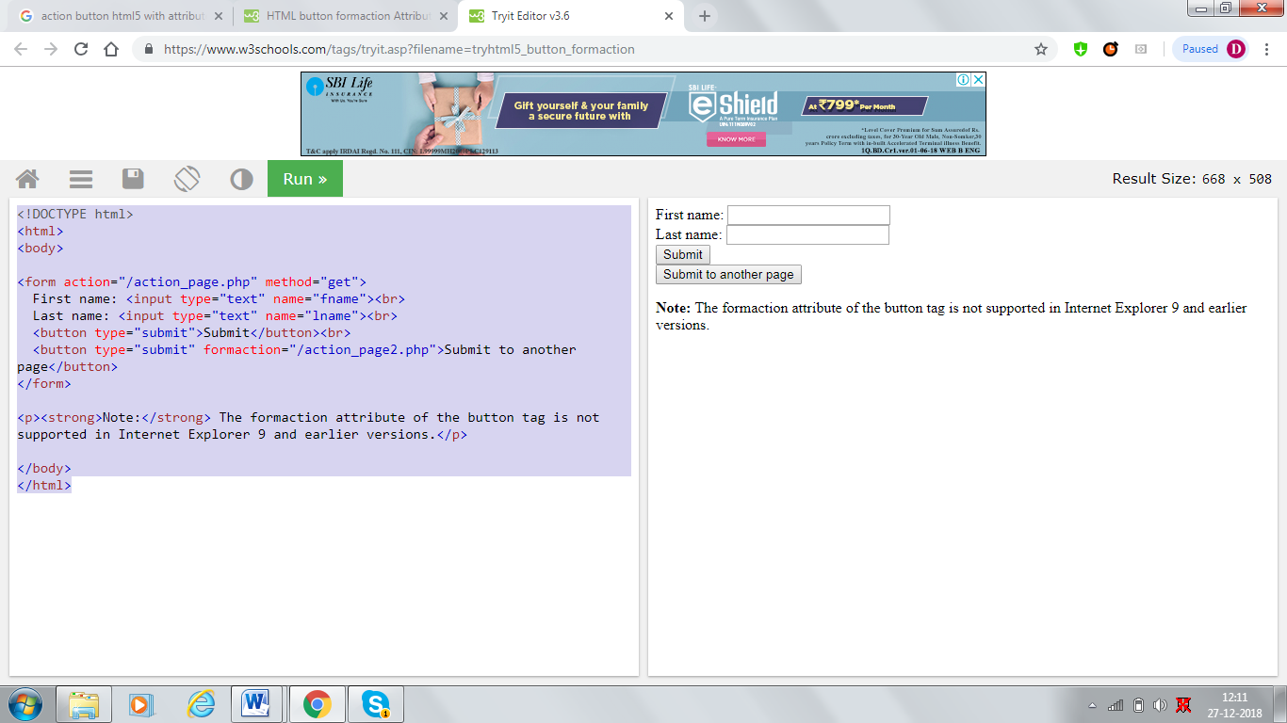

# HTML <link> target Attribute

## Syntax

<link target="_blank|_self|_parent|_top|*framename*">

## Attribute Values

|  |  |
| --- | --- |
| **Value** | **Description** |
| _blank | Load in a new window |
| _self | Load in the same frame as it was clicked |
| _parent | Load in the parent frameset |
| _top | Load in the full body of the window |
| *framename* | Load in a named frame |

<head>  
  <link rel="parent" href="wildcats.htm" target="_blank">  
</head>

## HTML Images

In HTML, images are defined with the <img> tag.

The <img> tag is empty, it contains attributes only, and does not have a closing tag.

The src attribute specifies the URL (web address) of the image:

<img src="*url*">

|  |  |  |
| --- | --- | --- |
| **Attribute** | **Value** | **Description** |
| [align](https://www.w3schools.com/tags/att_img_align.asp) | top bottom middle left right | Not supported in HTML5. Specifies the alignment of an image according to surrounding elements |
| [alt](https://www.w3schools.com/tags/att_img_alt.asp) | *text* | Specifies an alternate text for an image |
| [border](https://www.w3schools.com/tags/att_img_border.asp) | *pixels* | Not supported in HTML5. Specifies the width of the border around an image |
| crossorigin | anonymous  use-credentials | Allow images from third-party sites that allow cross-origin access to be used with canvas |
| [height](https://www.w3schools.com/tags/att_img_height.asp) | *pixels* | Specifies the height of an image |
| [hspace](https://www.w3schools.com/tags/att_img_hspace.asp) | *pixels* | Not supported in HTML5. Specifies the whitespace on left and right side of an image |
| [ismap](https://www.w3schools.com/tags/att_img_ismap.asp) | ismap | Specifies an image as a server-side image-map |
| [longdesc](https://www.w3schools.com/tags/att_img_longdesc.asp) | *URL* | Specifies a URL to a detailed description of an image |
| sizes |  | Specifies image sizes for different page layouts |
| [src](https://www.w3schools.com/tags/att_img_src.asp) | *URL* | Specifies the URL of an image |
| srcset | URL | Specifies the URL of the image to use in different situations |
| [usemap](https://www.w3schools.com/tags/att_img_usemap.asp) | *#mapname* | Specifies an image as a client-side image-map |
| [vspace](https://www.w3schools.com/tags/att_img_vspace.asp) | *pixels* | Not supported in HTML5. Specifies the whitespace on top and bottom of an image |
| [width](https://www.w3schools.com/tags/att_img_width.asp) | *pixels* | Specifies the width of an image |

# HTML5 - AUDIO & VIDEO

HTML5 features include native audio and video support without the need for Flash.

The HTML5 <audio> and <video> tags make it simple to add media to a website. You need to set **src** attribute to identify the media source and include a controls attribute so the user can play and pause the media.

## Embedding Video

Here is the simplest form of embedding a video file in your webpage −

<video src = "foo.mp4" width = "300" height = "200" controls>

Your browser does not support the <video> element.

</video>

The current HTML5 draft specification does not specify which video formats browsers should support in the video tag. But most commonly used video formats are −

* **Ogg** − Ogg files with Thedora video codec and Vorbis audio codec.
* **mpeg4** − MPEG4 files with H.264 video codec and AAC audio codec.

You can use <source> tag to specify media along with media type and many other attributes. A video element allows multiple source elements and browser will use the first recognized format −

<!DOCTYPE HTML>

<html>

<body>

<videowidth="300"height="200"controlsautoplay>

<sourcesrc="/html5/foo.ogg"type="video/ogg"/>

<sourcesrc="/html5/foo.mp4"type="video/mp4"/>

Your browser does not support the <video> element.

</video>

</body>

</html>

This will produce the following result −

## Video Attribute Specification

The HTML5 video tag can have a number of attributes to control the look and feel and various functionalities of the control −

|  |  |
| --- | --- |
| **Sr.No.** | **Attribute & Description** |
| 1 | **autoplay**  This Boolean attribute if specified, the video will automatically begin to play back as soon as it can do so without stopping to finish loading the data. |
| 2 | **autobuffer**  This Boolean attribute if specified, the video will automatically begin buffering even if it's not set to automatically play. |
| 3 | **controls**  If this attribute is present, it will allow the user to control video playback, including volume, seeking, and pause/resume playback. |
| 4 | **height**  This attribute specifies the height of the video's display area, in CSS pixels. |
| 5 | **loop**  This Boolean attribute if specified, will allow video automatically seek back to the start after reaching at the end. |
| 6 | **preload**  This attribute specifies that the video will be loaded at page load, and ready to run. Ignored if autoplay is present. |
| 7 | **poster**  This is a URL of an image to show until the user plays or seeks. |
| 8 | **src**  The URL of the video to embed. This is optional; you may instead use the <source> element within the video block to specify the video to embed. |
| 9 | **width**  This attribute specifies the width of the video's display area, in CSS pixels. |

## Embedding Audio

HTML5 supports <audio> tag which is used to embed sound content in an HTML or XHTML document as follows.

<audio src = "foo.wav" controls autoplay>

Your browser does not support the <audio> element.

</audio>

The current HTML5 draft specification does not specify which audio formats browsers should support in the audio tag. But most commonly used audio formats are **ogg, mp3** and **wav**.

You can use tag to specify media along with media type and many other attributes. An audio element allows multiple source elements and browser will use the first recognized format −

<!DOCTYPE HTML>

<html>

<body>

<audiocontrolsautoplay>

<sourcesrc="/html5/audio.ogg"type="audio/ogg"/>

<sourcesrc="/html5/audio.wav"type="audio/wav"/>

Your browser does not support the <audio> element.

</audio>

</body>

</html>

This will produce the following result −

## Audio Attribute Specification

The HTML5 audio tag can have a number of attributes to control the look and feel and various functionalities of the control −

|  |  |
| --- | --- |
| **Sr.No.** | **Attribute & Description** |
| 1 | **autoplay**  This Boolean attribute if specified, the audio will automatically begin to play back as soon as it can do so without stopping to finish loading the data. |
| 2 | **autobuffer**  This Boolean attribute if specified, the audio will automatically begin buffering even if it's not set to automatically play. |
| 3 | **controls**  If this attribute is present, it will allow the user to control audio playback, including volume, seeking, and pause/resume playback. |
| 4 | **loop**  This Boolean attribute if specified, will allow audio automatically seek back to the start after reaching at the end. |
| 5 | **preload**  This attribute specifies that the audio will be loaded at page load, and ready to run. Ignored if autoplay is present. |
| 6 | **src**  The URL of the audio to embed. This is optional; you may instead use the <source> element within the video block to specify the video to embed. |

## Handling Media Events

The HTML5 audio and video tag can have a number of attributes to control various functionalities of the control using JavaScript −

|  |  |
| --- | --- |
| **S.No.** | **Event & Description** |
| 1 | **Abort**  This event is generated when playback is aborted. |
| 2 | **Canplay**  This event is generated when enough data is available that the media can be played. |
| 3 | **Ended**  This event is generated when playback completes. |
| 4 | **Error**  This event is generated when an error occurs. |
| 5 | **loadeddata**  This event is generated when the first frame of the media has finished loading. |
| 6 | **loadstart**  This event is generated when loading of the media begins. |
| 7 | **Pause**  This event is generated when playback is paused. |
| 8 | **Play**  This event is generated when playback starts or resumes. |
| 9 | **progress**  This event is generated periodically to inform the progress of the downloading the media. |
| 10 | **ratechange**  This event is generated when the playback speed changes. |
| 11 | **Seeked**  This event is generated when a seek operation completes. |
| 12 | **Seeking**  This event is generated when a seek operation begins. |
| 13 | **Suspend**  This event is generated when loading of the media is suspended. |
| 14 | **volumechange**  This event is generated when the audio volume changes. |
| 15 | **Waiting**  This event is generated when the requested operation suchasplayback is delayed pending the completion of another operation. |

Following is the example which allows to play the given video −

<!DOCTYPE HTML>

<html>

<head>

</head>

<body>

<video width="320" height="240" controls>  
  <source src="movie.mp4" type="video/mp4">  
  <source src="movie.ogg" type="video/ogg">  
Your browser does not support the video tag.  
</video>

</body>

</html>

This will produce the following result −

## Configuring Servers for Media Type

Most servers don't by default serve Ogg or mp4 media with the correct MIME types, so you'll likely need to add the appropriate configuration for this.

AddType audio/ogg .oga

AddType audio/wav .wav

AddType video/ogg .ogv .ogg

AddType video/mp4 .mp4